Feature Image: "Luxury looks. Budget price."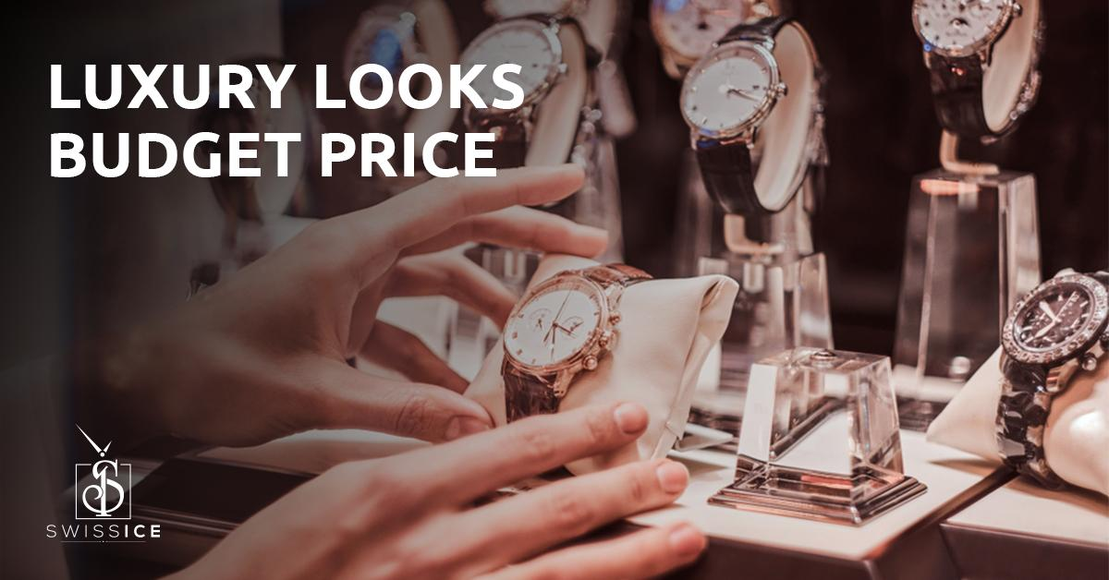

Title: Affordable Luxury Men Watches That Look Expensive
Focus Keyword: (3x)
Luxury Men Watches
Secondary Keyword:(1x)
best luxury watch brands
best watch brands
best watches for men

Internal Link
best watches for men: https://swissiceco.com/
Swiss Luxury timepieces: https://swissiceco.com/pages/watches

Word count: 1000
Meta Description:
Get affordable luxury Swiss watches exclusively at Swiss Ice Co. Authentic pre-owned timepieces from Rolex, Omega & Cartier that look million-dollar expensive.

Affordable Luxury Men Watches That Look Expensive H1
At SWISS ICE Co., our view is that you do not have to pay seven figures to enjoy a luxury men’s watch. Owning a Swiss luxury watch is not only about prestige, but also about how it makes you look more impressive without extra effort. Seasoned collectors as well as first-time buyers will find unparalleled quality, heritage, and reasonable prices in our carefully chosen collection of used luxury men’s watches. Let’s consider how you can purchase high-end men’s watches without spending a fortune.

Why Affordable Luxury Men Watches Are a Smart Investment H2
Beyond being everyday accessories, luxury men’s watches become family heirlooms and signify important achievements. But what defines “affordable luxury”? It entails combining the popularity of iconic designs with the craftsmanship of Switzerland, all at an accessible price. Discover reasons that make pre-owned luxury timepieces a breakthrough purchase.
- Cost Efficiency: Pre-owned watches are typically available for 30 to 50% less than what they cost initially.
- Timeless Appeal: The best watch brands such as Rolex, Omega, and Cartier stay fashionable and maintain their price for years.
- Sustainability: Choosing fashion with less waste supports circular fashion systems.
At SWISS ICE Co, we ensure our customers get only the authentic watches of the premier watch brand models which will gives you Swiss craftsmanship without a high price.

Key Elements That Make a Watch Look Expensive H2
Each brand produces luxury men’s watches of varying quality. This is what defines an excellent high-end timepiece:

1. Iconic Design: Timelessness Over Trends H3
Designs that resist current fashion trends define the most valuable watches for men. The Cartier Tank Solo is often considered a masterwork since it debuted in 1917 and took its shape from the tanks used in World War I. Those who admire the style icon style will definitely love to wear the Cartier due to its rectangular shape, sterile Roman numerals, and austere dial, illustrating that luxury is timeless. Much like the Cartier, the Rolex Datejust has, since 1945, embodied a refined masculine look through its fluted bezel and the magnifying Cyclops lens.
The greatest designs are marked by consistent proportions, readable dials, and easily identifiable brand traits. For example, the Seamaster’s wave dial and helium port, borrowed from diving, are unmistakable elements, and the IWC Portugieser’s signature numerals and track markers make it seem timelessly elegant. Beyond their stylistic use, these particulars act as survivor stories, reflecting both the brand’s artistry and history. Make choices based on luxury men’s watches that have endured as trendsetters for several decades. Because they have withstood the test of time, they will continually appear costly.

2. Premium Materials: Built to Impress (and Last) H3
Premium Swiss timepieces are built primarily with stainless steel, ceramic, titanium, and sapphire crystal, not simply because these are stylish materials. Next, let’s talk about why these materials make a difference:
- Stainless Steel: Roles Royce employs its own stainless steel formula, for example Oystersteel (904L steel), valued for protecting against corrosion and delivering a vivid mirror finish.
- Ceramic: Ceramic not only resists scratches and is easy to carry, but is also admired in models such as the Omega Speedmaster Dark Side of the Moon.
- Titanium: The matt finish and hypoallergenic titanium used in Tudor’s Pelagos Ultra give it a remarkably discrete luxury feel.
- Sapphire Crystal: Its near resistance to scratches makes sapphire glove crystal a commonly used feature in luxury watches including the Breitling Navitimer.
Even subtle details count. Manually applied enamel gloss on Patek Philippe Calatrava dials is a quality that plastic alternatives can never match. In addition, Hublot makes daring choices by offering carbon fiber structures or adding rose gold details. They offer both toughness and enduring style, so your watch will continue to look good for many years.

3. Heritage & Craftsmanship: The Soul of Swiss Luxury H3
Many elements contributing to a watch’s high price are found in its historical background. Timepieces sold by Patek Philippe and Audemars Piguet embody not only current design but also hundreds of years of innovative effort. Take Patek’s Calatrava: Its particular clous de Paris guilloche dial and carefully beveled edges receive countless hours of artisan care, resulting in the Geneva Seal certification.
In luxury men’s watches, it is the movement that provides its main function and value. A Rolex Submariner powered by Caliber 3235 demonstrates more than just accuracy. The movement is officially certified by COSC and is highly resistant to magnetism.
Each component and characteristic of a watch is examined at SWISS ICE Co., including both the precision of the oscillating weight and the presence of genuine hallmarks. Acquiring a pre-owned Swiss luxury watch from us allows you to become a part of horological history.

Top 5 Best Luxury Watch Brands for Affordable Iconic Pieces H2
We’ve handpicked brands that deliver luxury without compromise:

1. Rolex: The Undisputed King H3
- Why It’s Timeless: Rolex commands almost a third of the Swiss luxury watch market, while the Submariner and Daytona are regularly seen as luxury symbols.
- Affordable Pick: The Rolex Air-King (from $3,150 in the secondary market) keeps the beloved Oyster build and high precision of other Rolex models.

2. Cartier: Elegance Redefined H3
- Why It’s Timeless: Historical Art Deco designs are combined in Cartier’s Tank and Santos watches with precision Swiss movements.
- Affordable Pick: Although it is no longer produced, the Tank Solo, with resale values from $1,500, is considered a minimalist icon.

3. Omega: Innovation Meets Adventure H3
- Why It’s Timeless: Because they are NASA-approved and enjoyed by James Bond, Omega's Speedmaster and Seamaster models are considered legends.
- Affordable Pick: Priced at about $3,950 when resold, the Speedmaster Professional bears NASA’s seal of durability.

4. Tudor: Rolex’s Accessible Sibling H3
- Why It’s Timeless: Ownership by Rolex allows Tudor to reflect its parent company’s DNA while keeping costs down. The diver community loves the Black Bay and Pelagos from Tudor.
- Affordable Pick: Prices under $3,000 allow you to enjoy the vintage look of the Tudor Heritage Ranger.

5. Breitling: Precision for the Bold H3
- Why It’s Timeless: Inspired by aviation, the Navitimer chronograph helped pilots and became beloved for its style.
- Affordable Pick: You can purchase the Breitling Colt for its COSC-certified accuracy in a tough, military-type design.

How to Choose the Best Watches for Men? H2
These suggestions will help you choose the best watches for men for you:
- Prioritize Movement H3
  - Automatic: Automatic movements found in Rolex and Omega deliver quality and long-term performance.
  - Quartz: You can find less expensive, easily maintainable options, like the Breitling Colt, for everyday use.
- Focus on Versatility H3
  - The IWC Ingenieur matches a ceramic case to both formal and casual wear.
  - The Longines Conquest line combines sporty and dressy design motifs.
- Verify Authenticity H3
  - All watches sold by SWISS ICE Co. come with proper warranties and Certificates of Authenticity to prove they are genuine.

Where to Buy Affordable Luxury Men Watches? H3
Shopping for used luxury watches online is your top option. Here’s why:
- Curated Selection: Websites including SWISS ICE Co carefully examine every piece, so everything listed is an authentic Swiss luxury timepiece.
- Exclusive Access: These pre-owned markets often bring together rare options such as the Patek Philippe Nautilus or Audemars Piguet Royal Oak as their first listings.
- Customization: Changing the strap on a Cartier or Omega watch is a simple way to update your look.

Final Thoughts: H3
It is possible to find luxury men’s watches that do not break the bank and choosing them is a smart idea. Selecting pre-owned watches by the finest luxury brands means you are able to enjoy heritage, quality workmanship, and designs that never go out of fashion. Our commitment at SWISS ICE Co is to guide you to find Swiss luxury timepieces that are both desirable and affordable.
Ready to Explore? Take a look through our selection and find a watch that appears and is crafted to resemble a million-dollar timepiece.
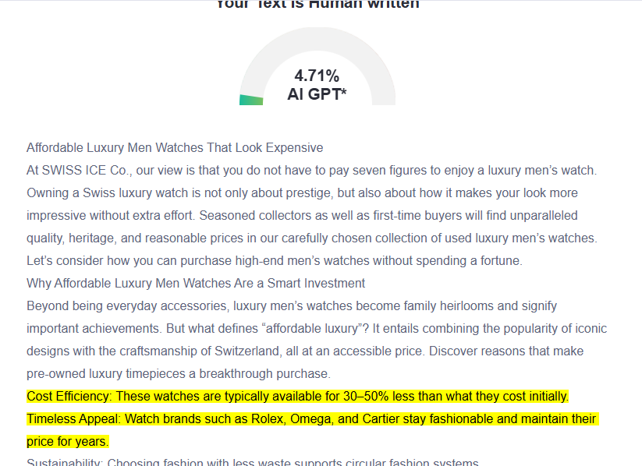

GMB
We at Swiss Ice Co offer the opportunity for anyone to own luxury watches. We are renowned for selling authentic, previously owned watches from famous Swiss brands such as Rolex, Omega, and Cartier. The watches in our meticulously selected collection are available at 30-50% below what they originally cost. We make certain that each watch meets rigorous standards through in-depth authentication. We hold that affordability and luxury can go hand in hand. Our attention is on timepieces made with superior materials, including stainless steel, ceramic, and sapphire crystal. All our watches provide a link to the Swiss tradition of precision and fine craftsmanship. Our customers acquire something more valuable than a simple watch. They acquire watches that are representative of horological history. We stock a selection of vintage and contemporary watches that are sure to make an impression without costing a fortune. We carefully guide you to pick the ideal watch that suits both your style and sophistication. Swiss Ice Co. brings together sustainability and luxury in every watch we sell. When you choose a pre-owned watch, you align with circular fashion and add a true work of design to your collection. We invite you to see our collection and find a watch that unites elegance with value and superior quality.

